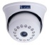
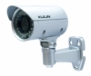
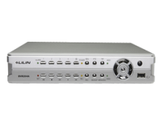
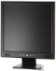
Indoor Camera Outdoor Camera DVR / NVR Monitor

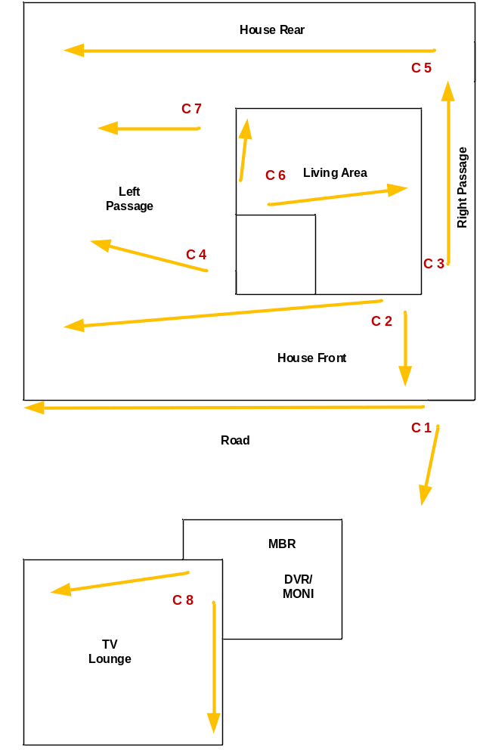
Customer Name | Dr. Lalantha Gurusinghe
Drawing Title | CCTV
Issue No | RE/TE
Issue Date | 24/8/2018
Revision No
Revision Date
Created By | Ajith Fernando
Approved By

